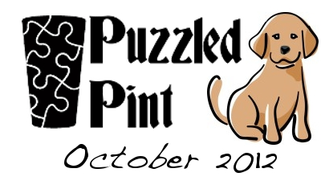
Dog Show Results
SOLUTION
- Note that each listed breed is a combination of two regular breeds PLUS an extra letter. Ordering the breeds alphabetically and reading those extra letters gives: “NAMESIZESSORT”.
- Thus, sort the breeds by the number of letters in their name. Solve the logic equations for each.
- Using the solved logic equations, pull letters out of each breed. For instance, if an equation for a given breed solves to 110 use the first and second letters of the breed.
- These extracted letters read “SECONDPLACERIBBONCOLOR”. The solution to the puzzle is “red” (or “scarlet”).

Length Order | Alpha Order | Name | Extra Letter | Breed1 | Breed2 | Logic Solution | Extracted Letters
1 | 11 | shelo-zu | O | sheltie | shih-tzu | 101 | SE
2 | 10 | scotsane | S | scottie | great dane | 011 | CO
3 | 6 | miniitiff | I | miniature poodle or mini schnauzer | mastiff | 001 | N
4 | 4 | dachsetese | E | daschund | maltese | 100 | D
5 | 8 | pinscheergi | E | pinscher | corgi | 100 | P
6 | 5 | labrasointer | S | labrador | pointer | 110 | LA
7 | 2 | chowaset hound | A | chow chow | basset hound | 100 | CO
8 | 7 | pekingezepherd | Z | pekingese | shepherd | 010 | E
9 | 9 | rottweishnauzer | S | rottweiler | schnauzer | 100 | R
10 | 12 | siberian hurpherd | R | siberian husky | shepherd | 011 | IB
11 | 1 | bonetland sheepdog | N | boston terrier | shetland sheepdog | 111 | BON
12 | 3 | collmador retriever | M | collie | labrador retriever | 111 | COL
13 | 13 | yorkshire tertnauzer | T | Yorkshire Terrier | schnauzer | 011 | OR

